How to record your dissertation video in the Presentation Studio (Main Library)
- Follow the directions for using the studio (copies of the directions are online and in the studio).
- Make sure that the green backdrop is set behind where you will stand.
- Check the camera’s view in the monitor to ensure the background is the green backdrop. Feel free to move the camera or use the stool, if needed.
- Special note:
  - If you will send a slide to be included, be sure to leave space at your side so it can be added (image 1)
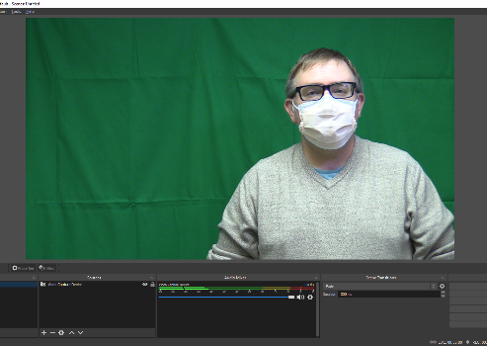
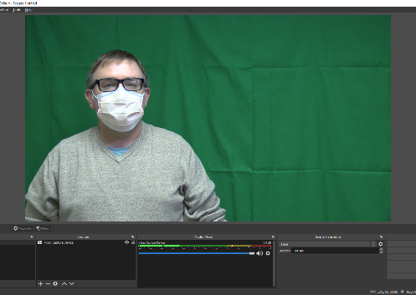

Image 1 – Allows Slide to Be Added
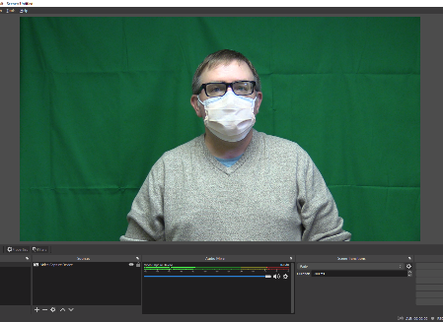
  - If you will not have a slide in your video, position yourself in the middle of the frame (image 2)

Image 2 – If No Slide Will Be Added
- Follow the directions to complete your recording and review it if you wish.
- Be sure to have a USB Dive to save your recording; alternatively, you can upload it to the cloud. You will not be able to email the recording due to the file size.
- There is no need to edit your video – the editing, including adding your opening and closing slides, will be completed by Graduate School staff.
- For any questions regarding the structure or content of the dissertation video, please contact the Disquisition Processor at ndsu.disq.processor@ndsu.edu.

